# **Draft Firebase Data Contract | Ruben Castaing | 23/03/2024**

1. Access

There are three main steps for gaining access, those are getting through security with a private key, installing the required packages and then querying the server.

Accessing the database will look different depending on the programming language used. The information below is for Python. If other languages are used, let Ruben know.

Security

Note the database doesn’t currently require a private key. However this is insecure. A private key will be required in future. I’ll add one here shortly.

Python install

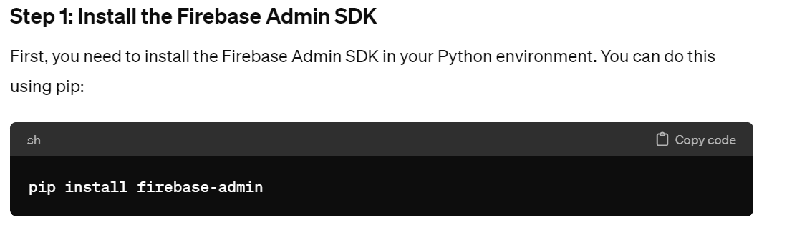

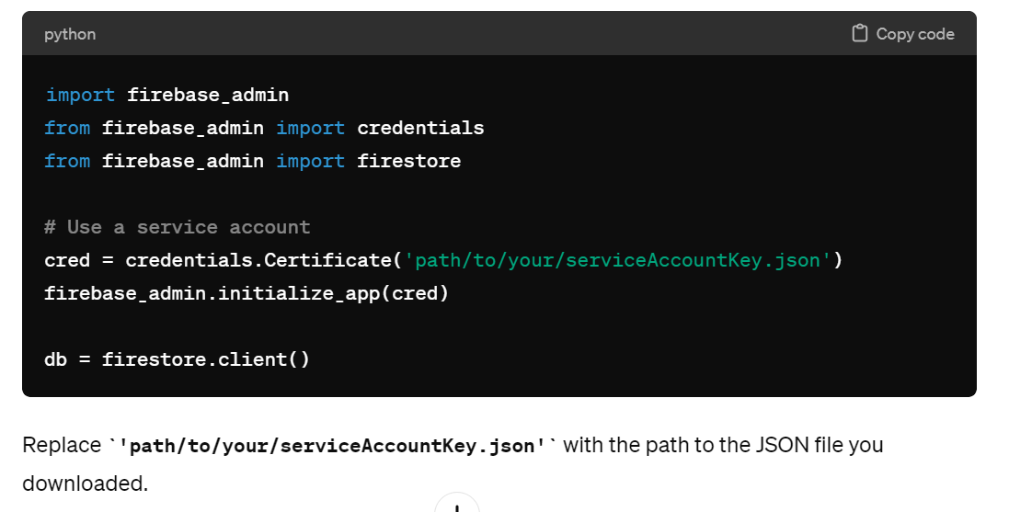

Querying the server

Ruben is willing to help with setting up server queries. This is the firebase documentation. <https://firebase.google.com/docs/firestore>. Below are some basic queries

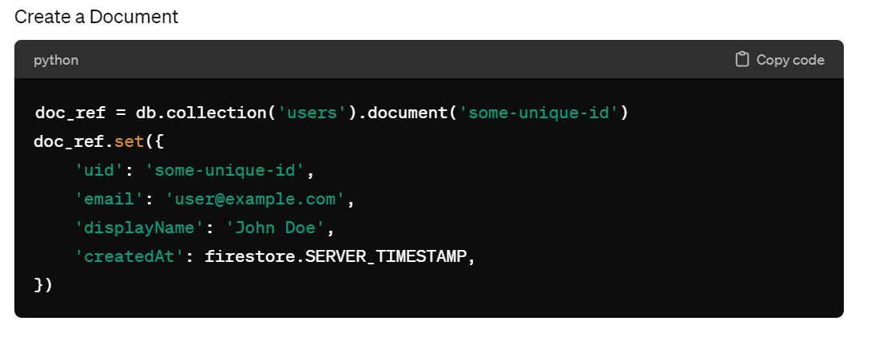

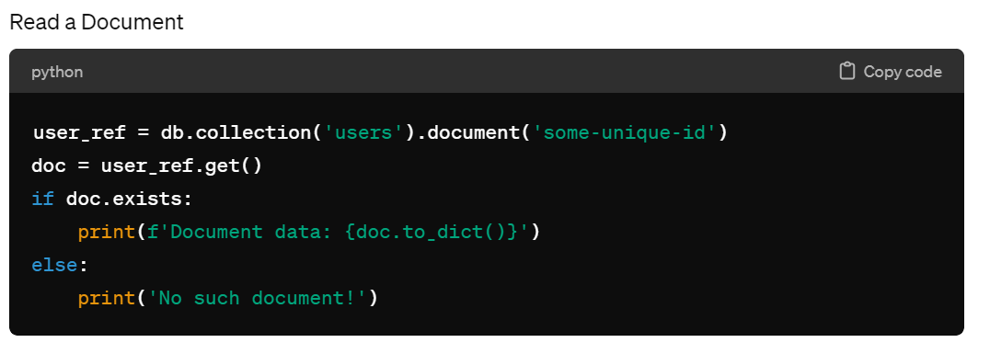

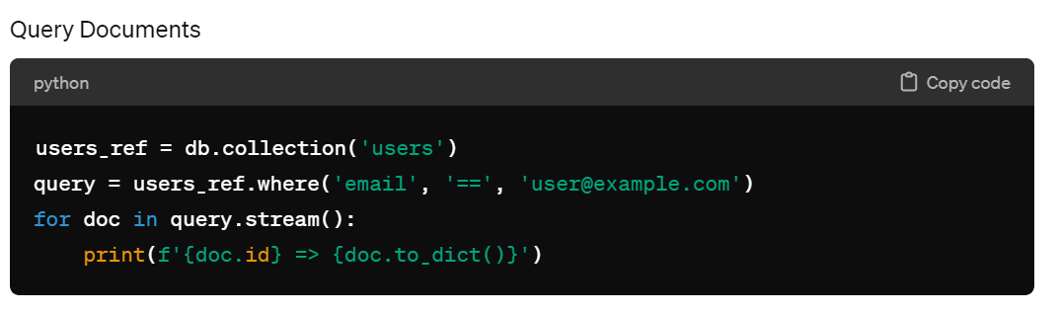

1. User Database Schema

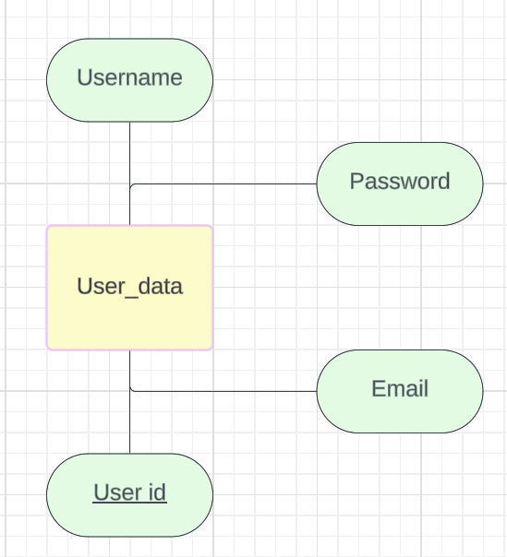

User data

* Id: string (Firebase Authentication UID) (Primary Key)
* email: string
* Username: string
* Password (string) (ensure these are hashed before going to the database)

These values are what I assume is needed. I’ll update some fields as I understand the requirements needed for authentication.

1. Database Schema for our modeling

I’ll write up this section once I know what data is required for our model.

1. Version

Database Version: v1

Schema Version: 1.0

1. Support

For support accessing the data, ask Ruben and I’ll help you access the data. I’m currently working out the details and thus cannot post good documentation about it.

1. Service Level Agreement (SLA)

The uptime of the database is largely dependent on firebase. If we pay a token fee, this can be up almost all of the time. Note firebase is done by Google so should be reliable.

1. Data Lineage

I’m currently uncertain where our data will be sourced from.